231501028

Aswini.G

AIML A

**EXPERIMENT 9**

AIM: To create an application using Kotlin to perform basic calculator operations like addition, subtraction, multiplication and deletion.

CODE:

MainActivity.kt

package com.example.simplecalcii  
  
import android.os.Bundle  
import android.widget.*  
import androidx.appcompat.app.AppCompatActivity  
  
class MainActivity : AppCompatActivity() {  
  
 override fun onCreate(savedInstanceState: Bundle?) {  
 super.onCreate(savedInstanceState)  
 setContentView(R.layout.*activity_main*)  
  
 // EditText for user input  
 val etNumber1 = findViewById<EditText>(R.id.*etNumber1*)  
 val etNumber2 = findViewById<EditText>(R.id.*etNumber2*)  
 // TextView to display result  
 val tvResult = findViewById<TextView>(R.id.*tvResult*)  
  
 // Buttons for calculator operations  
 val btnAdd = findViewById<Button>(R.id.*btnAdd*)  
 val btnSubtract = findViewById<Button>(R.id.*btnSubtract*)  
 val btnMultiply = findViewById<Button>(R.id.*btnMultiply*)  
 val btnDivide = findViewById<Button>(R.id.*btnDivide*)  
  
 // Add button action  
 btnAdd.setOnClickListener **{** val num1 = etNumber1.*text*.toString().*toDoubleOrNull*()  
 val num2 = etNumber2.*text*.toString().*toDoubleOrNull*()  
 if (num1 != null && num2 != null) {  
 val result = num1 + num2  
 tvResult.*text* = "Result: $result"  
 } else {  
 tvResult.*text* = "Invalid input!"  
 }  
 **}** // Subtract button action  
 btnSubtract.setOnClickListener **{** val num1 = etNumber1.*text*.toString().*toDoubleOrNull*()  
 val num2 = etNumber2.*text*.toString().*toDoubleOrNull*()  
 if (num1 != null && num2 != null) {  
 val result = num1 - num2  
 tvResult.*text* = "Result: $result"  
 } else {  
 tvResult.*text* = "Invalid input!"  
 }  
 **}** // Multiply button action  
 btnMultiply.setOnClickListener **{** val num1 = etNumber1.*text*.toString().*toDoubleOrNull*()  
 val num2 = etNumber2.*text*.toString().*toDoubleOrNull*()  
 if (num1 != null && num2 != null) {  
 val result = num1 * num2  
 tvResult.*text* = "Result: $result"  
 } else {  
 tvResult.*text* = "Invalid input!"  
 }  
 **}** // Divide button action  
 btnDivide.setOnClickListener **{** val num1 = etNumber1.*text*.toString().*toDoubleOrNull*()  
 val num2 = etNumber2.*text*.toString().*toDoubleOrNull*()  
 if (num1 != null && num2 != null) {  
 if (num2 == 0.0) {  
 tvResult.*text* = "Error: Division by zero!"  
 } else {  
 val result = num1 / num2  
 tvResult.*text* = "Result: $result"  
 }  
 } else {  
 tvResult.*text* = "Invalid input!"  
 }  
 **}** }  
}

activity_main.xml

<?xml version="1.0" encoding="utf-8"?>  
<LinearLayout xmlns:android="http://schemas.android.com/apk/res/android"  
 android:layout_width="match_parent"  
 android:layout_height="match_parent"  
 android:orientation="vertical"  
 android:padding="24dp"  
 android:gravity="center">  
  
 <!-- TextView for displaying result -->  
 <TextView  
 android:id="@+id/tvResult"  
 android:layout_width="match_parent"  
 android:layout_height="80dp"  
 android:gravity="end|center_vertical"  
 android:text="Result"  
 android:textSize="24sp"  
 android:textStyle="bold"  
 android:layout_marginBottom="20dp"  
 android:background="#E0E0E0"/>  
  
 <!-- EditText for first number input -->  
 <EditText  
 android:id="@+id/etNumber1"  
 android:layout_width="match_parent"  
 android:layout_height="60dp"  
 android:hint="Enter first number"  
 android:inputType="numberDecimal"  
 android:padding="16dp"  
 android:textSize="18sp" />  
  
 <!-- EditText for second number input -->  
 <EditText  
 android:id="@+id/etNumber2"  
 android:layout_width="match_parent"  
 android:layout_height="60dp"  
 android:hint="Enter second number"  
 android:inputType="numberDecimal"  
 android:padding="16dp"  
 android:textSize="18sp" />  
  
 <!-- Buttons for calculator operations -->  
 <GridLayout  
 android:layout_width="match_parent"  
 android:layout_height="wrap_content"  
 android:columnCount="2"  
 android:orientation="horizontal"  
 android:layout_gravity="center">  
  
 <!-- Button for Addition -->  
 <Button  
 android:id="@+id/btnAdd"  
 android:layout_width="120dp"  
 android:layout_height="60dp"  
 android:text="Add"  
 android:textSize="18sp" />  
  
 <!-- Button for Subtraction -->  
 <Button  
 android:id="@+id/btnSubtract"  
 android:layout_width="120dp"  
 android:layout_height="60dp"  
 android:text="Subtract"  
 android:textSize="18sp" />  
  
 <!-- Button for Multiplication -->  
 <Button  
 android:id="@+id/btnMultiply"  
 android:layout_width="120dp"  
 android:layout_height="60dp"  
 android:text="Multiply"  
 android:textSize="18sp" />  
  
 <!-- Button for Division -->  
 <Button  
 android:id="@+id/btnDivide"  
 android:layout_width="120dp"  
 android:layout_height="60dp"  
 android:text="Divide"  
 android:textSize="18sp" />  
 </GridLayout>  
</LinearLayout>

OUTPUT:

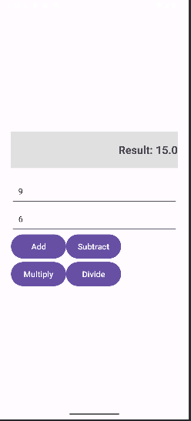

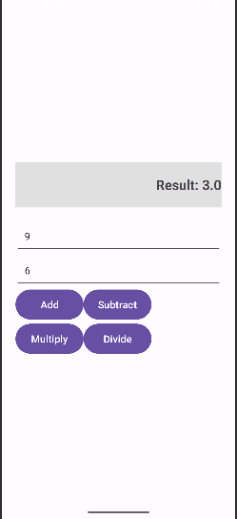

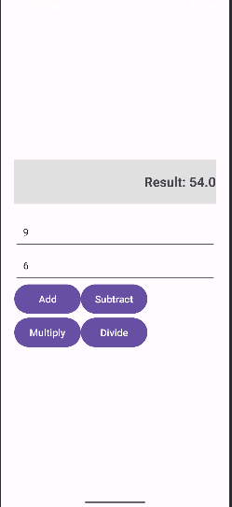

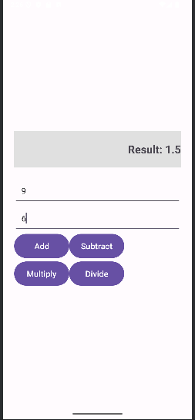

Result: APP SUCCESSFULLY DONE.